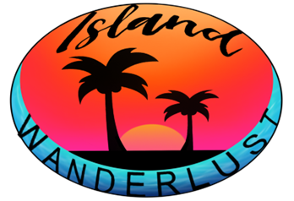

**Island Wanderlust**

**Currently Island Wanderlust offers three signature tours as shown in the table below.**

**Prices are listed per person.**

|  |  |  |
| --- | --- | --- |
| **Tour** | **Time** | **Price/**  **EC $** |
| Gros  Piton Hike | 9 a.m.  /  12 P.M. | $50 |
| Saltibus Waterfall | 9 a.m.  /  12 P.M. | $65 |
| West Coast Snorkel | 9 a.m.  /  12 P.M. | $75 |

***If you are interested in booking a tour please fill out the form below. Book now!!...***

***Do you dare to come with us to the other side?***

|  |
| --- |
| Customer Information |

|  |
| --- |
| First Name: Click or tap here to enter text.  Last Name: Click or tap here to enter text.  Gender: Male Female  Phone Number: Click or tap here to enter text.  Email Address: Click or tap here to enter text. |

|  |
| --- |
| Tour Information |

|  |
| --- |
| Name Of Tour: Choose an item.  Tour Date: Click or tap to enter a date.  Number in  touring party: Choose an item. |

***If you have any additional questions please contact us using our contact information below.***

**Company Contact Information:**

***Email Address: IslandWanderlustSLU@gmail.com***

***Phone Number: +1 (758) 758 000***

***Instagram Username: Island_Wanderlust_758***